**MUNDАRIJА**

**KIRISH**.................................................................................................................... **2**

1. **BOB. Ilova bilan tanishish ……………………………………………………………….**
   1. Masalaning qo’yilishi **……………………………………………………………… 3**

**1.2** Ilovaning tuzilishi .,,,,,,,…………………………………...……………... **4**

**1.3** Ilovaning sozlamalar bo`limi ………….….………………………………………..……………………. **7**

**II. BOB. Ilovani ishlab chiqish jarayoni …..…………….**

**2.1** Ilovaning texnik topshiriqlari ....................................................................... **8**

**XULOSA……………………………………………………………….....**

**ILOVA...........................................................................................................**

**KIRISH**

Hozirda Kompyuter va axborot texnologiyalari jadal sur’atlar bilan yangilanib, rivojlanishi bilan birga kundalik turmushimizning asosiga aylanib bormoqda.

Hozirgi kunda zamоnaviy talablarni hisоbga оlgan hоlda ma`lumоtlar tarmоg’ini tashkil qilishni takоmillashtirish, o`sib kelayotgan yosh avlоdning intellektual ehtiyojlarini qоndirishga, madaniy, ma`naviy-axlоqiy qadriyatlarni saqlab qоlishga yo`naltirilgan printsipial yangi axbоrоt markazlarini barpо etish, shuningdek, ahоlini yanada kengrоq va tizimli axbоrоt bilam ta`minlash uchun zarur shart-sharоitlar yaratish maqsadida O`zbekistоn Respublikasida ta`lim sоhasida quyidagilarni amalga оshirish ko`zda tutilgan:

* ta`lim muassasalari o`quvchilari hamda axоlining zamоnaviy axbоrоt texnоlоgiyalaridan fоydalangan hоlda muntazam ta`lim оlishi va mustaqil ravishda ta`lim оlishiga ko`maklashish;
* yangi axbоrоt texnоlоgiyalari
* asоsida ahоliga axbоrоt xizmati ko`rsatish;
* madaniy, ta`lim, axbоrоt hamda bоshqa dastur va lоyihalarni birgalikda amalga оshirish uchun ta`lim muassasalari, mahalliy o`zini o`zi bоshqarish о`rganlari, milliy madaniyat markazlari bilan xamkоrlikni rivоjlantirish.
* Respublikamizda ta`lim tizimida tub islоhatlar оlib bоrilmоqda. Shulardan yana biri masоfadan turib o`qitish sistemasining jоriy qilinishi. Bunda Respublikamiz оliygоhlarida malakali prоfessоrlarning ma`ruzalarini tinglash, bevоsita muloqat o`rnatish mumkin.
* Masоfaviy ta`lim sistemasining ishlab chiqilishi keyingi yillarda ta`lim xizmatiga bo`lgan talabning keskin o`sishi tufayli hamda uning ijtimоiy ahamiyatiga asоslangan hоlda sоdir bo`ladi.
* Ta`lim sоhasida elektrоn darslik va qo`llanmalarni yaratish uchun quyidagi muxim masalalarni hal qilish kerak bo`ladi.
* Internet texnоlоgiyasi bilan tanishib chiqish ;
* prоgramma vоsitalarini o`rganish, masalan Web -saytlarni yaratish va qayta ishlash bo`yicha;

**I BOB. Ilovani ishlab chiqish**

**1.1 Masalaning qo`yilishi**

Ilovani ishlab chiqish uchun biz asosiy 2 ta ish qilishimiz lozim. Ilovaning dizayn qismini yaratish va hisob-kitob qismini qiluvchi qismini qurishimiz lozim.

Biz ilova dizaynini Google tomonidan tavsiya etilgan Material design sayti orqali osongina yaratib olishimiz mumkun bo`ladi.

Ilova dizaynida asosan tugmalar, ma`lumot qabul qilish uchun maydonlar va natijani foydalanuvchiga ko’rsatish uchun dialog dan foydalaniladi.

Ilovaning hisob-kitob qismini bajarish uchun esa kotlin dasturlash tilidan foydalaniladi va developer.google.com sayti tomonidan tavsiya etilgan ko’rsatmalar orqali ilova qurilishi davom ettiriladi.

1.2 – rasm. Ilovaning tuzilishi

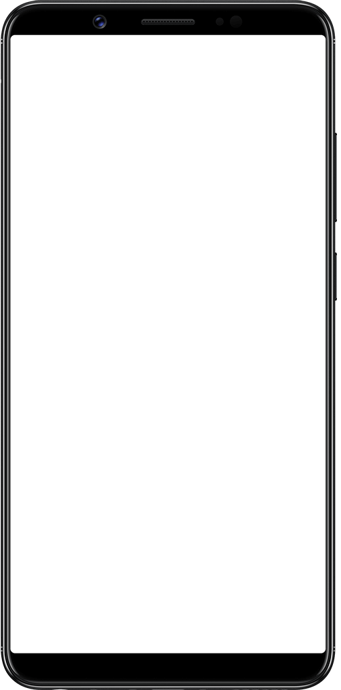Bu rasmda ilovaga foydalanuvchi birinchi marta tashrif buyurganda ilova ko’rinishi qanday bo’lishi ko’rsatilgan.

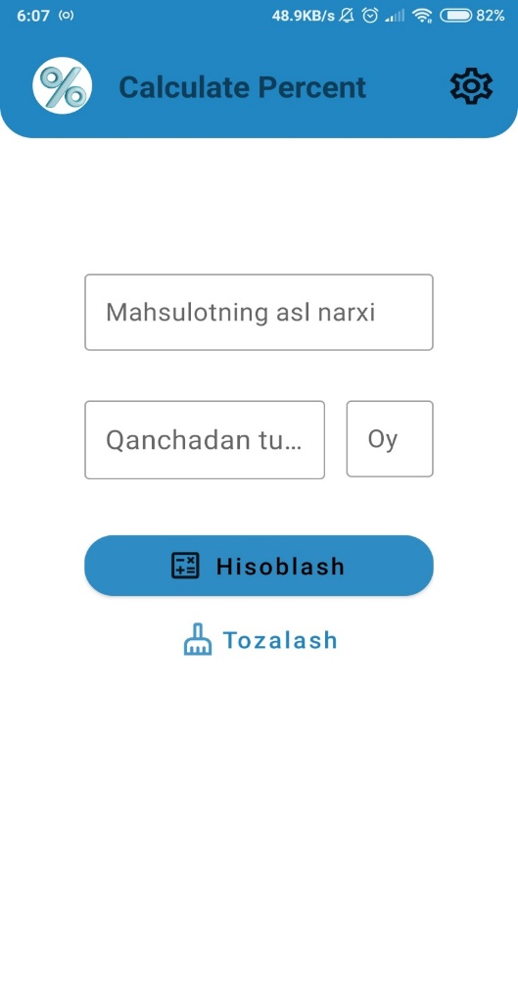

Componentlar

Ilova componentlari uchun Material design sayti tavsiya qilgan componentlar qo’llanildi.

Bu yerda ko’rish mumkunki: 3 ta foydalanuvchidan ma’lumotni oluvchi maydonlar, bitta hisoblash tugmasi va kiritilgan ma’lumotlarni tozalashga xizmat qiluvchi tugma mavjud.

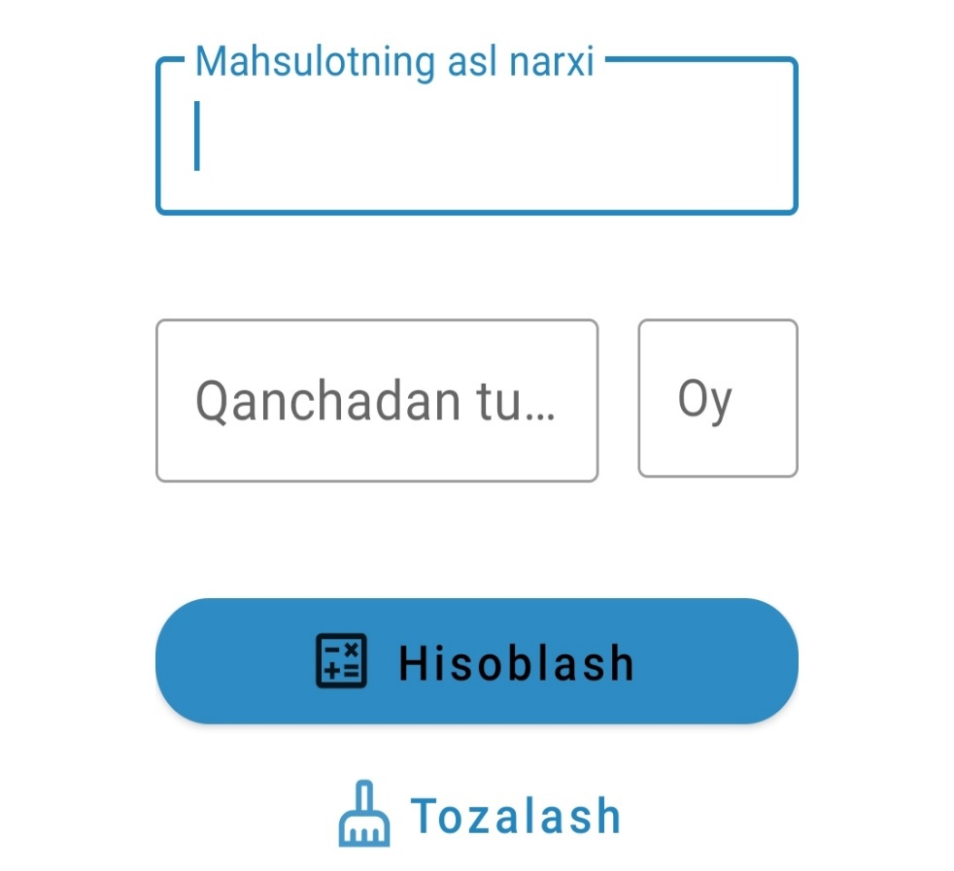

Sodir bo’lishi mumkun bo’lgan xatoliklarni oldi olindi

Foydalanuvchilar ilovadan foydalanish mobaynida har xil tasodiy xatoliklarga yo’l qo’yishi mumkun. Agar shunday holat bo’lgan ilova javob bermay qolsa yoki bo’lmasa foydalanuvchilarni etiroziga sabab bo’ladigan holatlar kuzatilsa, ular ilovadan ortiq foydalanmasligi mumkun.

Bu yerda agar foydalanuvchi umuman ma’lumot kiritmaganda yoki maydonlarni to’liq to’ldirmaganda, foydalanuvchiga dastur ogohlantirish yuborishi ko’rsatilgan.

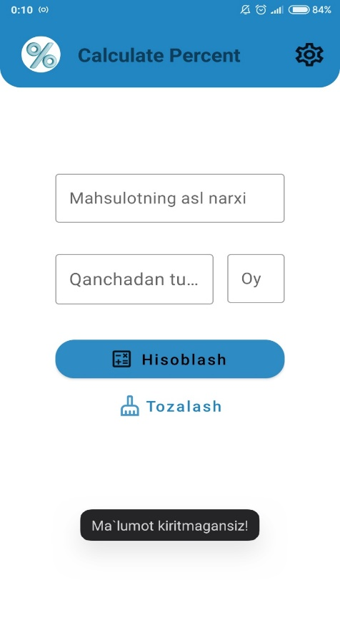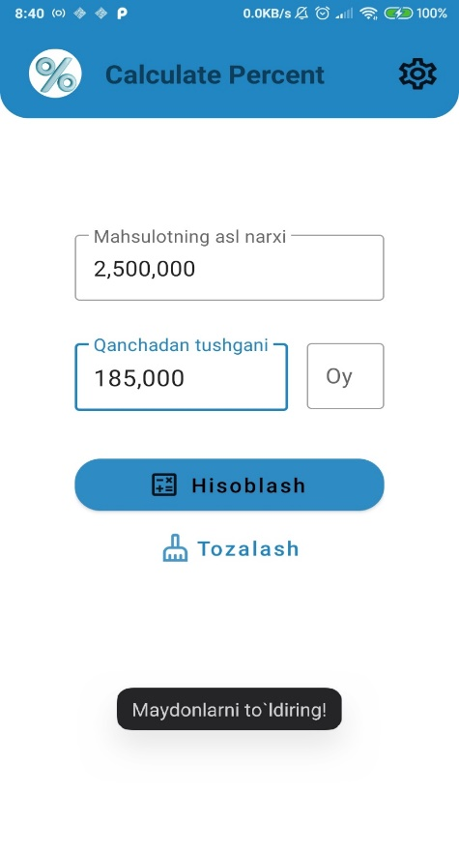

Ilovada natija oynasi

Agar foydalanuvchi hech qanday tasodiy xatoliklarga yo’l qo’ymay maydonlarni to’ldirib ‘Hisoblash’ tugmasini bosadigan bo’lsa natija quyidagicha bo’ladi.



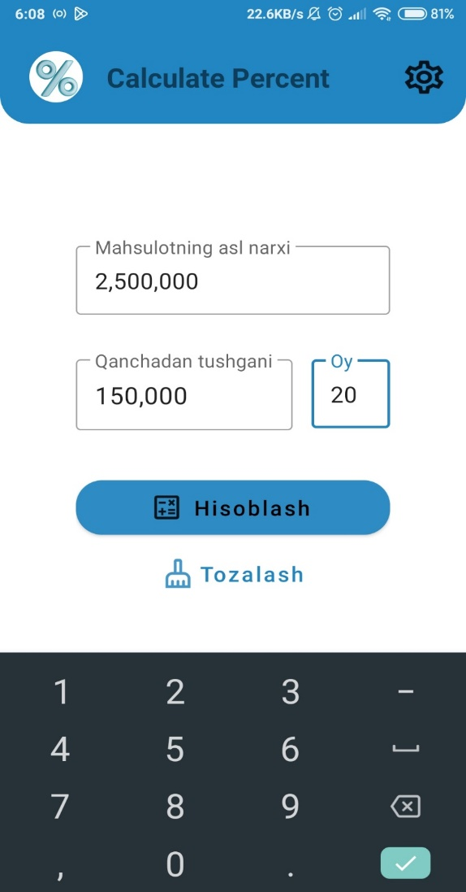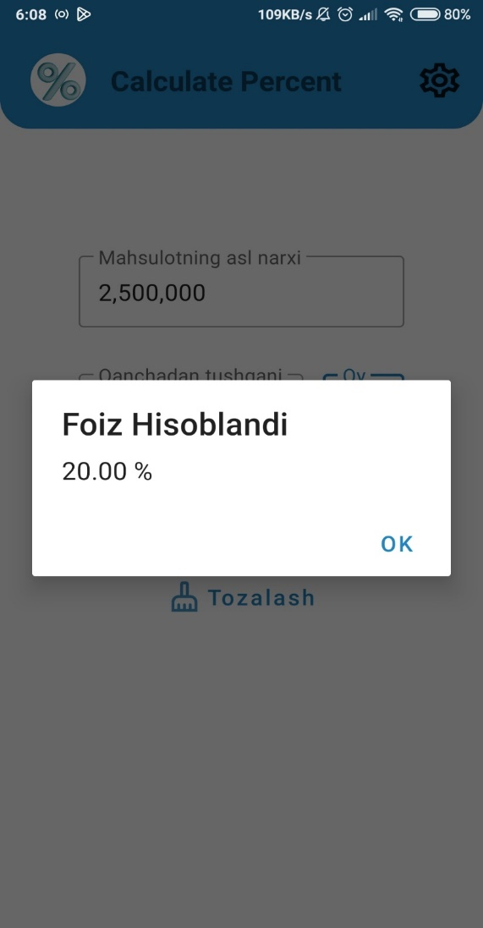

**1.3 – rasm. Ilovada Sozlamalar bo’limi**

Har bir ilovada bo’lgani kabi bu ilovada ham foydalanuvchiga ayrim yengilliklar va dasturning ba’zi jihatlarni o’zgartirish imkonini berish uchun bu ilovaga ham Sozlamalar bo’limi qo’shildi. Bu yerda hozircha ilova haqida ma’lumot olish va ilovani ulashish imkoni mavjud.

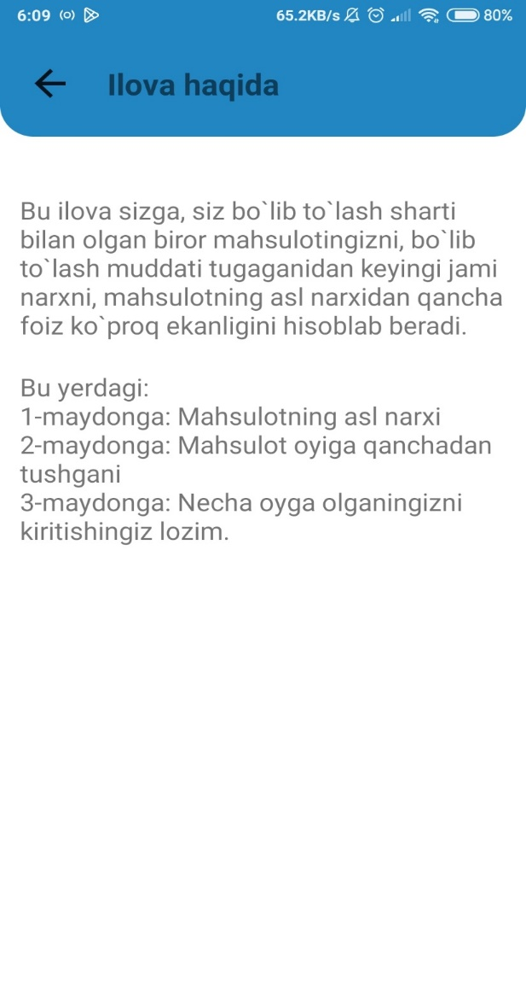

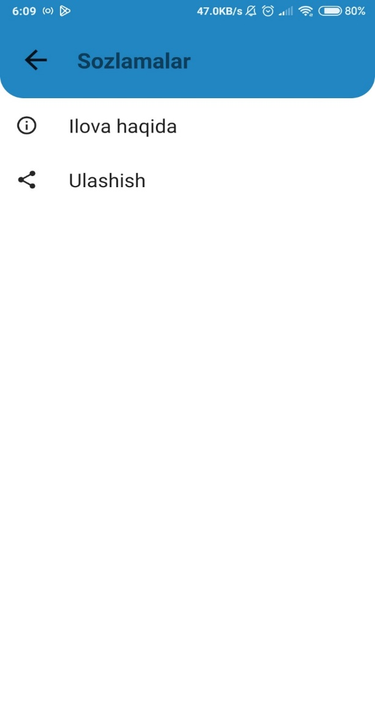

**2.2. Ilovaning texnik topshiriqlari**

**Texnik topshiriq** – tizimni ishlab chiqish jarayonida mijozlar tomonidan qo`yilgan talablarni dasturchilarga tushunarli tilda va tartibda kengroq yoritilgan shaklidir. Texnik topshiriqlar dasturchilar uchun juda muhimdir. Chunki texnik topshiriq orqali dasturchilar tizimning to’laligicha mohiyatini tushunib olishadi.

Aniq va puxta ishlab chiqilgan texnik topshiriq har qanday ilovani muvaffaqiyatli rivojlantirishning kalitidir. Bunday hujjatlar mavjud bo'lganda, buyurtmachi ham, dasturchi ham har ikki tomon ham bir xil yo'nalishda o'ylashlariga va loyihaning mohiyati va mazmunini teng darajada tushunishiga amin bo'lishlari mumkin.

Ilova uchun to'g'ri tayyorlangan texnik topshiriq ikkala tomonga qanday o'ziga xos afzalliklarni beradi.

**Texnik topshiriqlar mijozni himoya qiladi**. Vijdonsiz dasturchi bilan ishlashda (afsuski, bunday dasturchilar ham bor), Texnik topshiriqlar asosiy shartnomaga ilova sifatida sifatsiz xizmatlarga nisbatan mijozning asosiy argumenti bo'lib xizmat qiladi.

**Texnik topshiriqlar g'oyalarni tuzishda yordam beradi**. Ko'pincha, mijozlar ishlab chiquvchilarga butunlay noaniq va tarqoq fikrlar, so'zlar va istaklar bilan murojaat qilishadi. Natija qanday bo'lishi kerakligini tushunishga erishish juda qiyin - siz hamma narsani inobatga olishingiz va bitta hujjatga to'plashingiz kerak.

Texnik topshiriqlar byudjetni tejaydi. Yaxshi o'ylangan texnik vazifa mavjud bo'lganda, ilovani yaratish jarayonida muammolar (va shuning uchun qo'shimcha xarajatlar) ehtimoli nolga tenglashadi.

**Ilova uchun texnik topshiriqning asosiy bo'limlari** "Texnik topshiriqda nima bo'lishi kerak?" - loyihani tasdiqlash bosqichida mijozlar biz bilan bog'lanadigan asosiy savolga javob olish uchun ilova uchun texnik topshiriqning eng muhim bo'limlari bilan tanishib chiqishingizni tavsiya qilamiz.

**Loyihaning texnik xususiyatlari** Ko'pgina fikrlar sizga ma'lum qiyinchiliklarni keltirib chiqarishi mumkinligiga qaramay, kelajakdagi ilovaning texnik xususiyatlari haqidagi ma'lumotlar barcha talablarga javob beradigan loyihani ishlab chiqishda yordam beradi.

**XULOSA**

Xulosa qilib shuni aytish mumkunki, Hozirda hayotni axborot texnologiyalarsiz tasavvur qilib bo`lmaydi. Foydalanuvchilarga qulayliklar yaratish uchun Axborot texnologiyalaridan keng qo`llaniladi. Shu sababli maishiy texnika sotadigan do`konlarimizda ham savdo-sotiq jarayonlarni avtomatik hisoblash uchun qulay, foydali ilovalar zarur.

Ilovani yaratish davomida quyidagi Bilim va ko`nikmalar o`zlashtirildi:

“Material design 2” style ni componentlarda qo`llash.

“Activity”lar orasida munosabatlar bo`yicha bilim va ko`nikmalarimni mustahkamladim.

“Dialog”lardan ilova ichida unumli foydalanishni o`zlashtirdim

**Intеrnеt resurslari**

1. www.edu.uz – O’zbekiston respublikasi oliy va o’rta maxsus ta’lim vazirligi sayti.

2. <https://www.w3schools.com/html/>  
3. https://developer.android.com/  
5. http://www.google.com

4. www.ziyonet.uz – Ziyonet internet tarmog’i.

**Ilovada foydalanilgan codelar**

package ru.startandroid.calculatepercent  
  
import android.annotation.SuppressLint  
import android.content.Intent  
import android.os.Bundle  
import android.widget.Toast.*  
import androidx.appcompat.app.AlertDialog  
import androidx.appcompat.app.AppCompatActivity  
import ru.startandroid.calculatepercent.databinding.ActivityMainBinding  
import java.util.*  
  
class MainActivity : AppCompatActivity() {  
  
 private lateinit var binding: ActivityMainBinding  
 private var myTextWatcherObj = NumberTextWatcherForThousand  
  
 @SuppressLint("SuspiciousIndentation")  
 override fun onCreate(savedInstanceState: Bundle?) {  
 super.onCreate(savedInstanceState)  
 setContentView(R.layout.activity_main)  
  
 binding = ActivityMainBinding.inflate(layoutInflater)  
 setContentView(binding.root)  
  
  
 binding.apply {  
 etPriceShown.addTextChangedListener(NumberTextWatcherForThousand(etPriceShown))  
 etPriceReceived.addTextChangedListener(NumberTextWatcherForThousand(etPriceReceived))  
  
 btnCalculate.setOnClickListener {  
  
 var priceShown = etPriceShown.text.toString()  
 var priceReceived = etPriceReceived.text.toString()  
  
 if (priceShown.isNotEmpty() && priceReceived.isNotEmpty() && etMonth.text!!.isNotEmpty()) {  
 priceShown = myTextWatcherObj.trimCommaOfString(priceShown)  
 priceReceived = myTextWatcherObj.trimCommaOfString(priceReceived)  
  
 val priceShownDouble = priceShown.toDouble()  
 val priceReceivedInt = priceReceived.toInt()  
 val month = etMonth.text.toString().toInt()  
  
 if (priceReceivedInt*month>priceShownDouble){  
 val resultPercent = (priceReceivedInt*month - priceShownDouble)/priceShownDouble * 100  
 alert("Foiz Hisoblandi", "${String.format("%.2f",resultPercent)} %")  
 }else{  
 alert("Ogohlantirish","Noto`g`ri qiymat kiritdingiz!")  
 }  
  
 }else{  
 toast("Maydonlarni to`ldiring!")  
 }  
 }  
  
 btnClear.setOnClickListener{  
 if (etPriceShown.text!!.isNotEmpty() || etPriceReceived.text!!.isNotEmpty() || etMonth.text!!.isNotEmpty()) {  
 etPriceShown.setText("")  
 etPriceReceived.setText("")  
 etMonth.setText("")  
 }else{  
 toast("Ma`lumot kiritmagansiz!")  
 }  
 }  
 }  
  
 binding.ivSettings.setOnClickListener{  
 val intent = Intent(this,SettingsActivity::class.java)  
 startActivity(intent)  
 }  
  
 }  
  
 private fun alert(titleMessage:String, message:String){  
 val alertDialog: AlertDialog = AlertDialog.Builder(this)  
 .setTitle(titleMessage)  
 .setMessage(message)  
 .setPositiveButton("OK") { dialogInterface, _ -> dialogInterface.dismiss() }  
 .create()  
 alertDialog.show()  
 }  
  
 private fun toast(toastMessage: String) {  
 makeText(this,toastMessage, LENGTH_SHORT).show()  
 }  
  
}

<?xml version="1.0" encoding="utf-8"?>  
<LinearLayout xmlns:android="http://schemas.android.com/apk/res/android"  
 xmlns:app="http://schemas.android.com/apk/res-auto"  
 xmlns:tools="http://schemas.android.com/tools"  
 android:layout_width="match_parent"  
 android:layout_height="match_parent"  
 android:orientation="vertical"  
 tools:context=".MainActivity">  
  
 <androidx.constraintlayout.widget.ConstraintLayout  
 android:id="@+id/linearLayout"  
 android:layout_width="match_parent"  
 android:layout_height="85dp"  
 android:background="@drawable/shape"  
 android:orientation="horizontal"  
 app:layout_constraintEnd_toEndOf="parent"  
 app:layout_constraintHorizontal_bias="0.0"  
 app:layout_constraintStart_toStartOf="parent"  
 app:layout_constraintTop_toTopOf="parent">  
  
 <ImageView  
 android:id="@+id/imageView"  
 android:layout_width="45dp"  
 android:layout_height="45dp"  
 android:layout_marginStart="20dp"  
 android:background="@drawable/img"  
 android:contentDescription="@string/action_bar"  
 app:layout_constraintBottom_toBottomOf="parent"  
 app:layout_constraintStart_toStartOf="parent"  
 app:layout_constraintTop_toTopOf="parent"  
 app:layout_constraintVertical_bias="0.533" />  
  
 <TextView  
 android:id="@+id/textView"  
 android:layout_width="wrap_content"  
 android:layout_height="wrap_content"  
 android:layout_marginStart="20dp"  
 android:text="@string/app_name"  
 android:textSize="18sp"  
 android:textStyle="bold"  
 app:layout_constraintBottom_toBottomOf="@+id/imageView"  
 app:layout_constraintStart_toEndOf="@+id/imageView"  
 app:layout_constraintTop_toTopOf="@+id/imageView" />  
  
 <ImageView  
 android:id="@+id/ivSettings"  
 android:layout_width="40dp"  
 android:layout_height="35dp"  
 android:background="@drawable/ic_settings_icon"  
 android:contentDescription="@string/info"  
 app:layout_constraintBottom_toBottomOf="@+id/textView"  
 app:layout_constraintEnd_toEndOf="parent"  
 app:layout_constraintHorizontal_bias="0.85"  
 app:layout_constraintStart_toEndOf="@+id/textView"  
 app:layout_constraintTop_toTopOf="@+id/textView" />  
 </androidx.constraintlayout.widget.ConstraintLayout>  
  
 <com.google.android.material.textfield.TextInputLayout  
 style="@style/Widget.MaterialComponents.TextInputLayout.OutlinedBox"  
 android:layout_width="match_parent"  
 android:layout_height="wrap_content"  
 android:layout_marginLeft="64dp"  
 android:layout_marginTop="100dp"  
 android:layout_marginRight="64dp"  
 android:hint="@string/price_shown">  
  
 <com.google.android.material.textfield.TextInputEditText  
 android:id="@+id/etPriceShown"  
 android:layout_width="match_parent"  
 android:layout_height="wrap_content"  
 android:inputType="numberDecimal"  
 android:textSize="15sp" />  
  
 </com.google.android.material.textfield.TextInputLayout>  
  
 <LinearLayout  
 android:layout_width="match_parent"  
 android:layout_height="wrap_content"  
 android:layout_marginLeft="64dp"  
 android:layout_marginTop="32dp"  
 android:layout_marginRight="64dp"  
 android:baselineAligned="false">  
  
 <com.google.android.material.textfield.TextInputLayout  
 style="@style/Widget.MaterialComponents.TextInputLayout.OutlinedBox"  
 android:layout_width="match_parent"  
 android:layout_height="wrap_content"  
 android:layout_marginEnd="16dp"  
 android:layout_weight="1"  
 android:hint="@string/price_received"  
 android:textSize="15sp">  
  
 <com.google.android.material.textfield.TextInputEditText  
 android:id="@+id/etPriceReceived"  
 android:layout_width="match_parent"  
 android:layout_height="wrap_content"  
 android:inputType="numberDecimal" />  
  
 </com.google.android.material.textfield.TextInputLayout>  
  
 <com.google.android.material.textfield.TextInputLayout  
 style="@style/Widget.MaterialComponents.TextInputLayout.OutlinedBox"  
 android:layout_width="match_parent"  
 android:layout_height="wrap_content"  
 android:layout_weight="3"  
 android:hint="@string/month">  
  
 <com.google.android.material.textfield.TextInputEditText  
 android:id="@+id/etMonth"  
 android:layout_width="match_parent"  
 android:layout_height="wrap_content"  
 android:inputType="numberDecimal"  
 android:textSize="15sp" />  
  
 </com.google.android.material.textfield.TextInputLayout>  
  
 </LinearLayout>  
  
 <LinearLayout  
 android:layout_width="match_parent"  
 android:layout_height="wrap_content"  
 android:layout_marginLeft="64dp"  
 android:layout_marginTop="44dp"  
 android:layout_marginRight="64dp"  
 android:orientation="vertical">  
  
 <Button  
 android:id="@+id/btnCalculate"  
 style="@style/Widget.MaterialComponents.Button.Icon"  
 android:layout_width="match_parent"  
 android:layout_height="wrap_content"  
 android:layout_gravity="center"  
 android:layout_marginBottom="10dp"  
 android:background="@drawable/button_style"  
 android:text="@string/count"  
 android:textAllCaps="false"  
 app:icon="@drawable/ic_calculate_icon"  
 app:iconGravity="textStart"  
 app:iconSize="28dp" />  
  
 <Button  
 android:id="@+id/btnClear"  
 style="@style/Widget.MaterialComponents.Button.TextButton.Icon"  
 android:layout_width="wrap_content"  
 android:layout_height="wrap_content"  
 android:layout_gravity="center"  
 android:background="@drawable/button_style"  
 android:text="@string/clear"  
 android:textAllCaps="false"  
 app:icon="@drawable/ic_clear_icon"  
 app:iconGravity="textStart"  
 app:iconSize="28dp" />  
  
 </LinearLayout>  
  
</LinearLayout>